BRAIN-TARGETED TEACHING
LEARNING UNIT

Teacher: Michelle Dawson Dates: 4 weeks
Unit Topic:/Title: Proportional Sleuths! Grade Level: 7-8
Standard(s):
Common Core:
- 7.RP Analyze proportional relationships and use them to solve real-world and mathematical problems
- 8.EE Understand the connections between proportional relationships, lines, and linear equations.
Maryland State Curriculum:
- 7.3.C.2.a Determine a missing dimension for a figure using a scale
- 7.3.C.2.b: Determine the distance between two points using a drawing and a scale
- 7.6.C.3: Analyze ratios, proportions, and percents
- 8.6.C.3: Use proportional reasoning to solve measurement problems
- 8.6.C.3.c: Solve problems using proportional reasoning

Brain Target #1
Emotional Connection:

Connecting to the content:

* Guest Speaker: sources include American Institute of Architects – Baltimore (located on Chase St.) and/or a local architect

* Arts integration: self-portraits/facial proportions
Sources: Frida Kahlo
-- http://www.pbs.org/weta/fridakahlo/guides/teachers_artistic.html
-- Me, Frida, by Amy Novesky and David Diaz

Brain Target #2
Physical Environment:

* Incorporate theme of proportional reasoning into the classroom environment
-- Artwork/photographs: “real-life” portraits vs. distorted images, i.e., Manet/Cassat vs. Escher/Penrose
-- Maps: world/country/city/neighborhood
-- Models: planes/boats/cars/buildings

* Introduce these displays throughout the unit in order to introduce novelty into the room and also to correspond with lesson topic

Brain Target #3

Concept Map / Advanced Organizer:

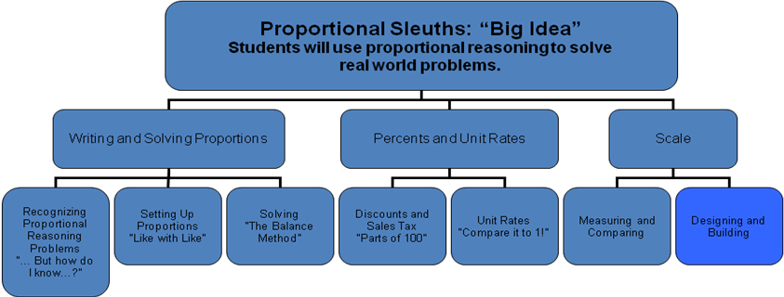

Learning Goals:

The Learning Goals for each of the three categories (Writing and Solving Proportions, Percents and Unit Rates, and Scale) are organized through the use of concept maps as well. These concept maps are enlarged and posted in the classroom with the “Big Idea” graphic organizer. The purpose of this is to allow students to visualize how these “seemingly different” ideas relate to each other. It also makes them aware that they already have the skills to solve these different problems because they all relate to the same basic idea of proportional reasoning. Therefore, they see the repetition of “Building My Proportion” and “Writing My Proportion” across all Learning Goals.

Writing and Solving: Students will be able to
* Recognize characteristics of proportions.
* Identify real-life applications of proportional reasoning.
* Set up a proportion.
* Solve a proportion.

Percents and Unit Rates: Students will be able to
* Identify and solve for unit rates by comparing to “1.”
* Identify and solve for percents by comparing to “100.”
* Use knowledge of unit rates and percents to determine sales prices and best buy.
* Set up a proportion.
* Solve a proportion.

Scale: Students will be able to
* Determine distance between two points using a ruler and scale.
* Use proportional reasoning to solve measurement problems.
* Determine the missing dimension for a figure using scale.
* Set up a proportion.
* Solve a proportion.

Introductory “Big Picture” Activity/Assessment of Prior Knowledge

* “Searching for Sales”
-- Video on Frugal TV “The Value Size Isn’t Always A Value,” at http://www.youtube.com/watch?v=WPDfkv295T4&feature=related
-- Students receive circulars from two different stores and respond to “Where would you buy…, and why?” product questions for items listed in both circulars.
-- Responses on chart paper, hanging in classroom for later reference (especially refer to them as students start to work on their Dream Room project and may realize that their responses to this initial activity need to be reworked!

Brain Target #4
Activities for Teaching Declarative/Procedural Knowledge
* Writing and Solving Proportions:
-- “Demonstrate and Illustrate” for students needing support with proportional reasoning concepts either not mastered in sixth grade or forgotten since then
* Proportional Reasoning
* Cross-Multiplication
* Percents and Unit Rates, Scale:
-- Introduction of “Dream Room” final project
-- Real-life application/repeated rehearsal of concepts
* Scale model of dream room
-- Determine amount of flooring and paint needed
-- Determine cost based on provided advertisements for sales
-- Complete two-dimensional model of dream room
-- Build three-dimensional model of dream room, to scale
* Process chart: student-generated chart of steps needed to create this scale model, along with explanation of mathematical concepts used (students choose between a written essay, a powerpoint presentation, or a video of their explanations and analysis)

Brain Target #5
Activities for Extension and Application of Knowledge
* Arts Integration:
-- Trip to Baltimore Museum of Art: Prints, Drawings, & Photographs collections (view works discussed throughout unit regarding proportion)
-- Students can prepare for trip via interactive activities on the museum’s website, http://www.artbma.org

* Real-Life Application:
-- Visit ACE Hardware (Waverly) – review paint can sizes/prices and other Dream Room supplies based on student’s projects
-- Analyze unit pricing of supplies needed for Dream Rooms, and also purchase supplies for 3D models

* Dream Room Showcase:
-- Students display scale drawings and 3D models, along with their presentations (the student-generated “process charts,” referenced in Brain Target 4)

Brain Target #6
Evaluating Learning

* Portfolio Development:
-- Student portfolios contain all material covered in unit, organized in three chapters corresponding with Learning Goals (Writing and Solving, Percents and Unit Rates, Scale)

* End of Unit written test: given to assess knowledge learned and also to gauge performance on standardized tests; perform error analysis on student responses to determine gaps in knowledge and develop reteaching activities

* Project Rubric: developed to evaluate acquisition of math concepts and their in-depth analysis, as well as to allow for (and give credit to) creativity on the part of the student
-- See rubric below.

 | Math Concept | Analysis of Project | Room Components | Design
3 | Scale is correctly used. Dimensions are calculated correctly and you show all work on your worksheet. | You have a well thought out process, justification, and analysis. | You have included at least 4 components in your room. | Your design reflects your interests. You have an appropriate amount of space to move around the room.
2 | Scale is almost always correctly used. Dimensions are almost always correctly calculated and you show all work on your worksheet. | Some of your process, justification, and analysis are incorrectly ordered or not well-justified. | You have included 3 components in your room. | Your design reflects your interests. You may have some difficulty moving around the room.
1 | There is little or no evidence of use of scale. You do not show all work. | Your analysis may be difficult to follow. | You have fewer than three components in your room. | Your design is generic and does not necessarily reflect your interests. You may not be able to move around the room.

Materials:
BT1:
Frida Kahlo information/lesson plan: http://www.pbs.org/weta/fridakahlo/guides/teachers_artistic.html
Frida Kahlo book: Me, Frida, by Amy Novesky and David Diaz

BT2:
Artwork/photographs: “real-life” portraits vs. distorted images, i.e., Manet/Cassat vs. Escher/Penrose
Maps: world/country/city/neighborhood
Models: planes/boats/cars/buildings

BT3:
Poster-sized version of graphic organizers (for unit and for learning goals)

“Big Picture” Activity:
Video on Frugal TV “The Value Size Isn’t Always A Value,” at http://www.youtube.com/watch?v=WPDfkv295T4&feature=related
Advertisement circulars from two different stores, advertising different prices for the same products
Chart paper/markers

BT4:
Proportional reasoning and cross-multiplication grids and graphic organizers
Dream Room assignments
Grid paper/colored pencils/scissors/rulers
Stiff poster board
Computer/video access (for student analysis of process)

BT5:
Baltimore Museum of Art’s website: http://www.artbma.org
ACE Hardware’s advertisements for paint prices/sales (if available at the time of the trip)
Unit pricing worksheet and clipboards for students to carry along

BT6:
Folders/containers for student portfolios (sizes may differ depending on student activities)
Unit Test
Project Rubrics

